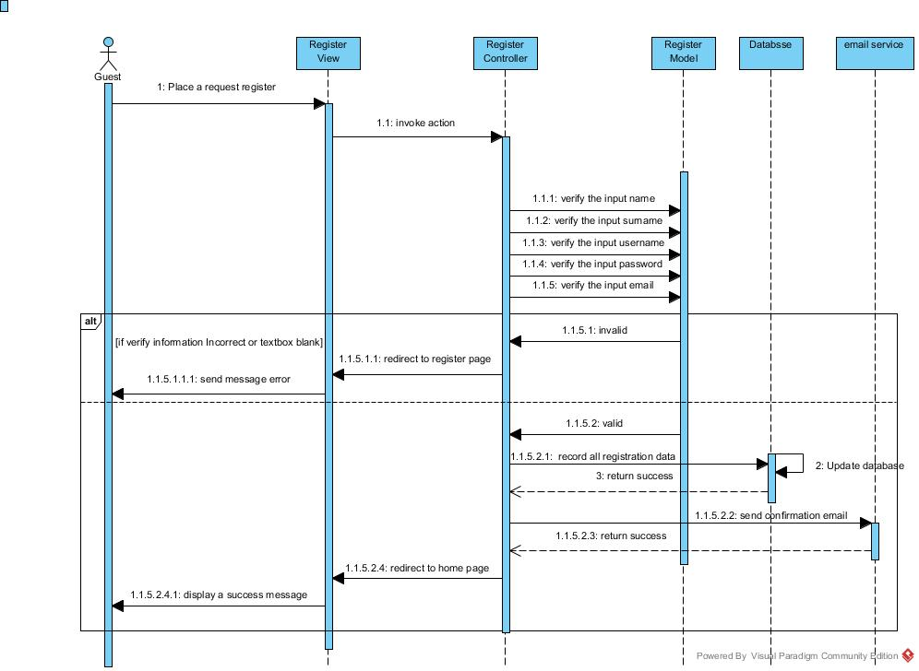

Guest can register to be a member of Wat ChaiMongKol Website.

Sequence diagram of “Wat ChaiMongKol” SD-01

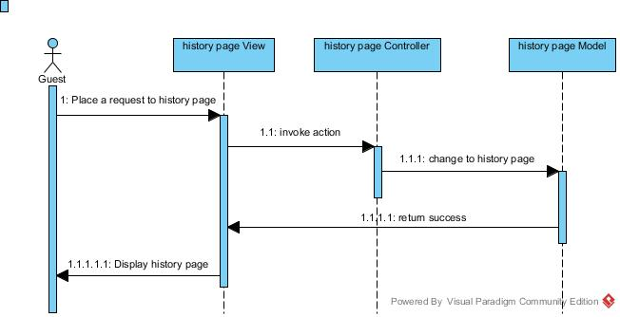

Guest can view the temple’s history.

Sequence diagram of “Wat ChaiMongKol” SD-02

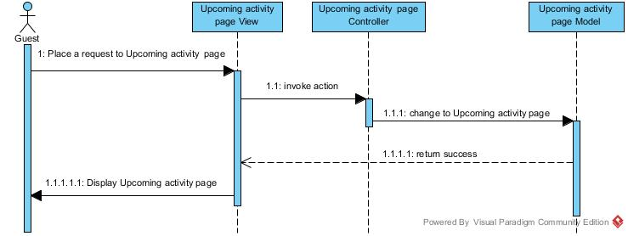

Guest can view upcoming activity.

Sequence diagram of “Wat ChaiMongKol” SD-03

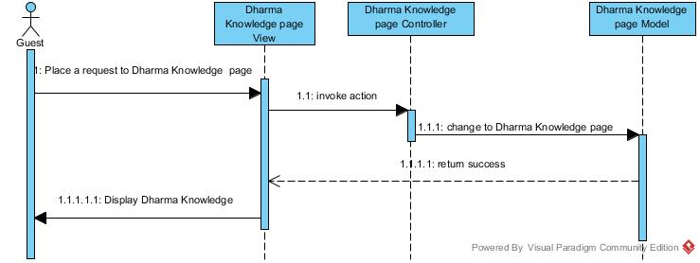

Guest can view Dharma Knowledge.

Sequence diagram of “Wat ChaiMongKol” SD-04

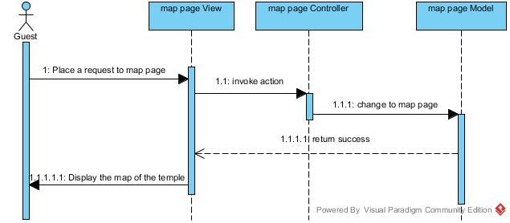

Guest can view the map of the temple.

Sequence diagram of “Wat ChaiMongKol” SD-05

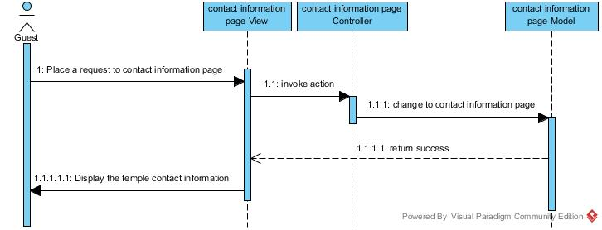

Guest can view the temple’s contact information.

Sequence diagram of “Wat ChaiMongKol” SD-06

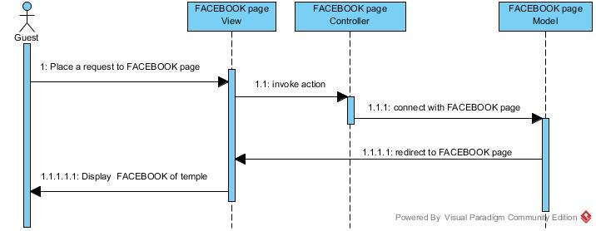

Guest can link directly to the temple’s facebook page.

Sequence diagram of “Wat ChaiMongKol” SD-07

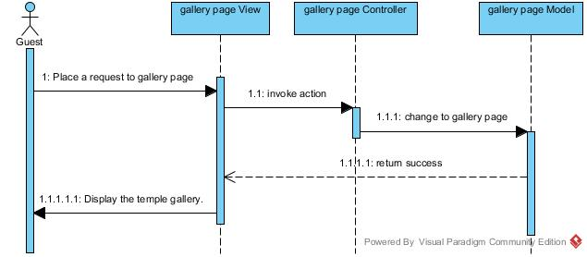

Guest can view the temple’s gallery.

Sequence diagram of “Wat ChaiMongKol” SD-08

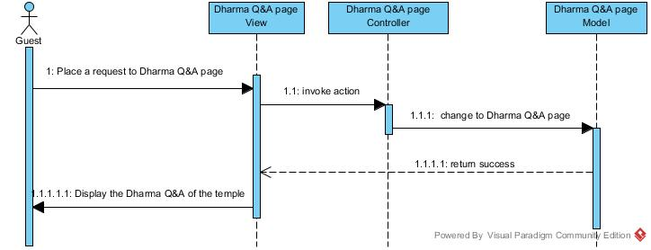

Guest can view the Dharma Q&A thread.

Sequence diagram of “Wat ChaiMongKol” SD-09

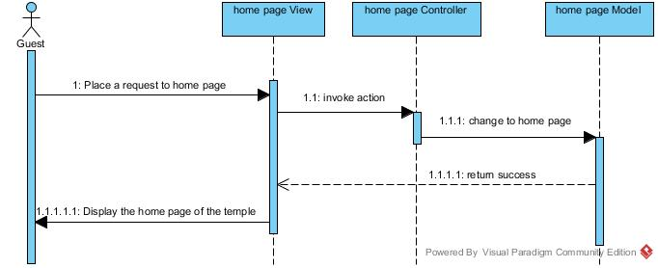

Guest can view the homepage of the temple’s website.

Sequence diagram of “Wat ChaiMongKol” SD-10

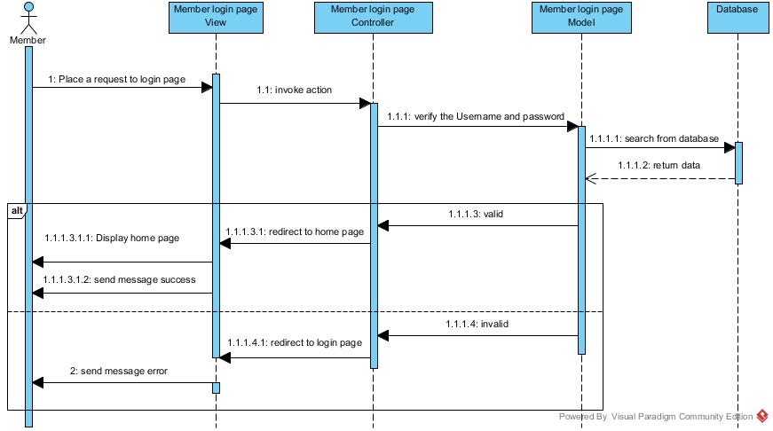

Member can login to the temple’s website as a member.

Sequence diagram of “Wat ChaiMongKol” SD-11

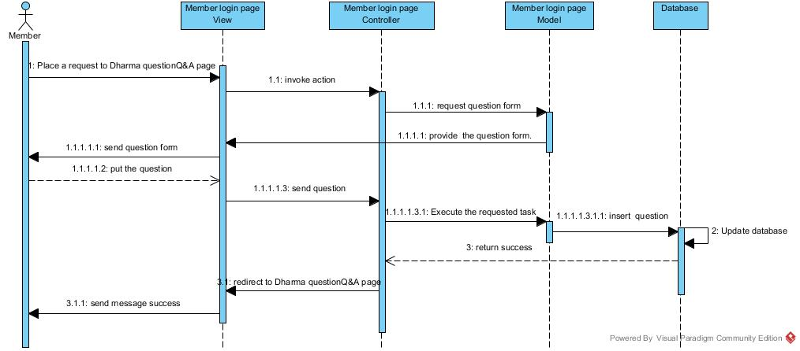

Member can ask any Dharma question via Q&A thread.

Sequence diagram of “Wat ChaiMongKol” SD-12

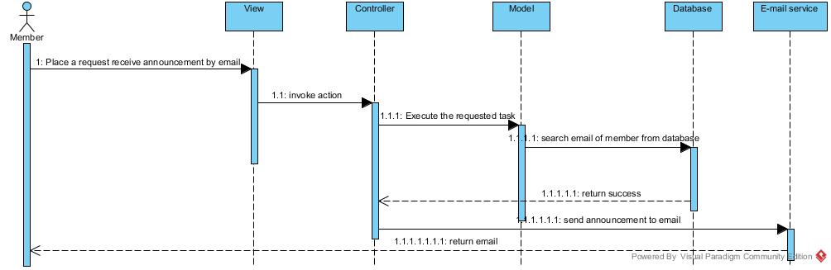

Member can receive the activity announcement via the registered email.

Sequence diagram of “Wat ChaiMongKol” SD-13

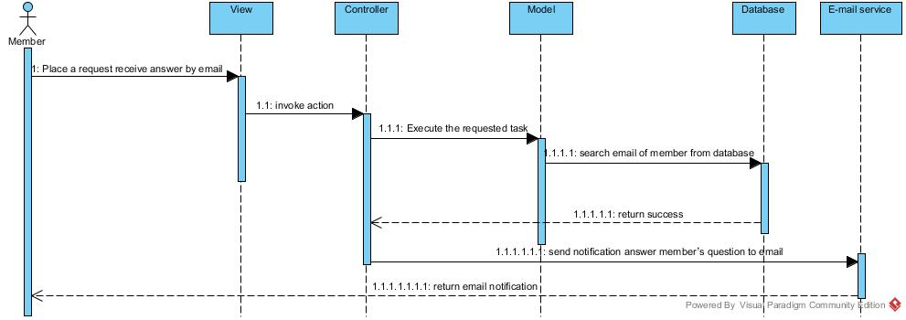

Member can receive the notification when the admin answer member’s question.

Sequence diagram of “Wat ChaiMongKol” SD-14